Data Preprocessing Pipeline
Summary Analysis Report
Missing Value Analysis · Imputation · Outlier Detection

1. Dataset Overview
The dataset contains clinical/biological measurements with hormonal, lipid, antioxidant, and metabolic markers. After initial loading and variable cleaning, the following structure was established:

Total Observations | 1,148 records
Initial Variables | 41 columns (before preprocessing)
Working Variables | 31 columns (after removing derived indices and outcome)
Variable Types | All numeric (hormones, lipids, antioxidants, metabolic markers)
Target Variable | outcome (binary: 0/1 — removed from imputation set)

Variables removed in the preparation stage included derived index columns (h_index_34, h_index_56, an_index_23), binary outcome flags (factor_eth, factor_h, factor_pcos, factor_prl), and the outcome column itself, leaving 31 variables for the missing value analysis pipeline.

2. Missing Value Analysis
A comprehensive audit of missingness was performed across all 31 working variables. The dataset had a total of 6,608 missing values, representing an 18.6% overall missingness rate — as visualised in the heatmap below.

Figure 1: Missing Data Heatmap (vis_miss)
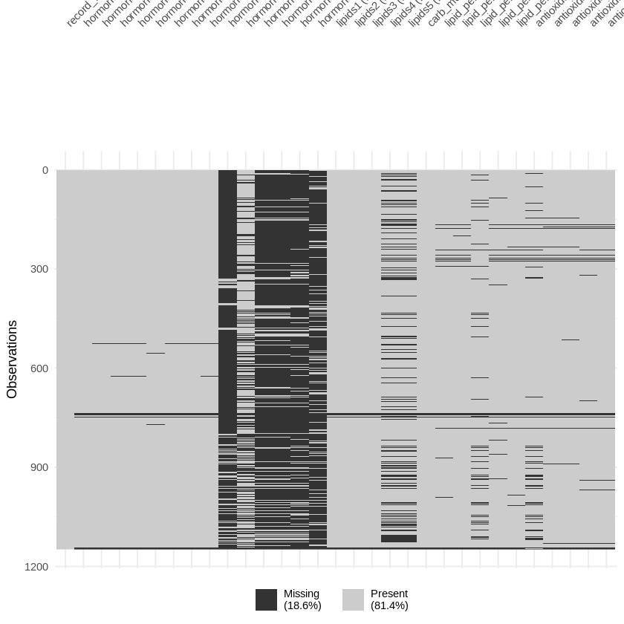
Figure 1 — Heatmap of NA patterns across all 1,148 observations and 31 variables. Black = missing (18.6%), grey = present (81.4%).
The heatmap reveals that most variables have sparse and scattered missingness except for a dense block in the middle columns — corresponding to hormone9 through hormone14 — which are almost entirely missing. The pattern suggests these high-missingness variables are structurally absent (data was never collected) rather than missing at random.

Figure 2: Missing Values Per Variable (gg_miss_var)
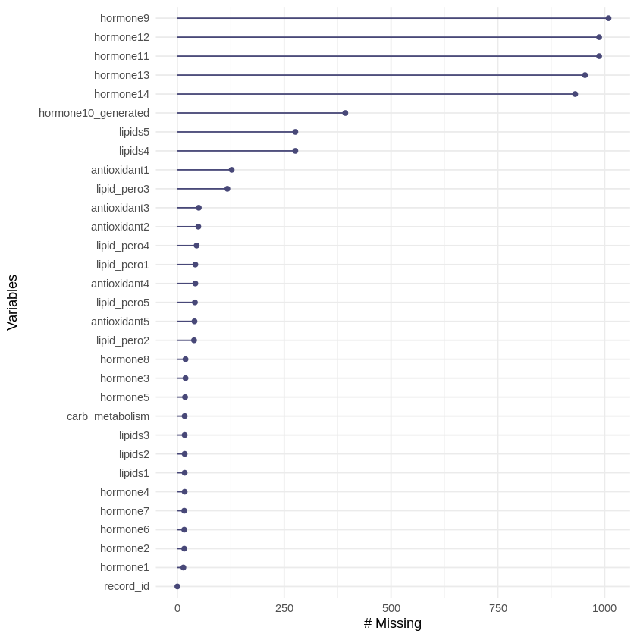
Figure 2 — Lollipop chart ranking all variables by absolute count of missing values.
The per-variable breakdown reveals two distinct groups:
- High-missingness group (>85%): hormone9 (~1,009 missing), hormone11, hormone12, hormone13, hormone14 (~931–987 missing). These 5 variables are almost entirely absent from the dataset.
- Moderate missingness: hormone10_generated (~393 missing, 34.2%), lipids4 and lipids5 (~276 missing, 24.0%).
- Low missingness (<12%): All remaining variables — hormones 1–8, lipids1–3, lipid_pero1–5, antioxidants1–5, carb_metabolism — with missingness rates of 1.2%–11.1%.

Decision taken: The five extreme-missingness variables (hormone9, hormone11–14) were dropped from the analysis entirely. The remaining 26 variables (including hormone10_generated at 34.2%) were retained for imputation.

3. Missing Value Imputation
Two multiple imputation strategies were applied using the MICE (Multivariate Imputation by Chained Equations) package with m = 5 imputations. Quality of imputation was evaluated by comparing the distribution of imputed values against observed values for the most challenging variable: hormone10_generated (34.2% missing).

Figure 3: RF Imputation — Density Plot (hormone10_generated)
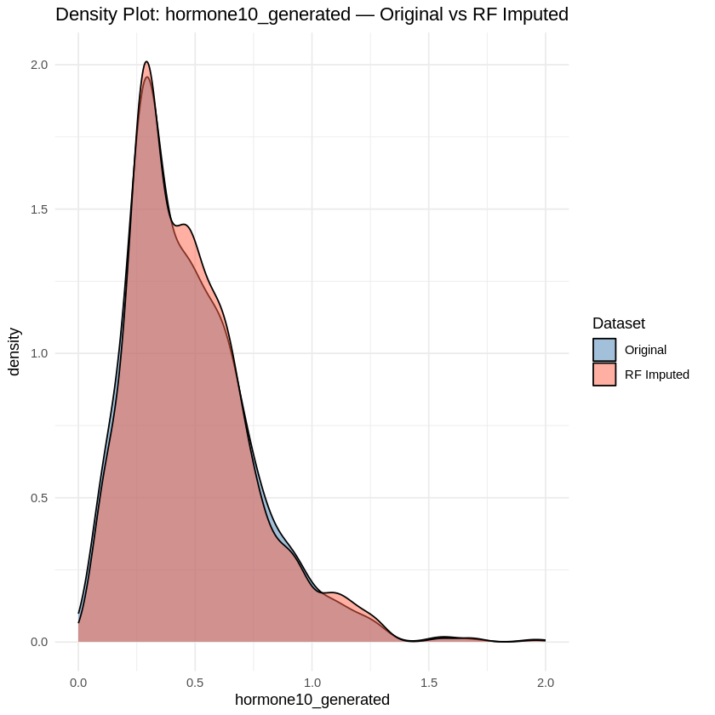
Figure 3 — Density comparison: Original distribution (blue) vs Random Forest imputed values (red/orange).
The Random Forest imputation (method = 'rf') produces an imputed distribution that closely mirrors the original. Both curves peak sharply near 0.3, with a right-skewed tail extending to ~2.0. The overlap is near-perfect — the RF method successfully learns the underlying distribution from observed data and fills gaps without distorting the shape. The slight broadening of the peak in the imputed data is expected as the model introduces minor variance.

Figure 4: PMM Imputation — Density Plot (hormone10_generated)
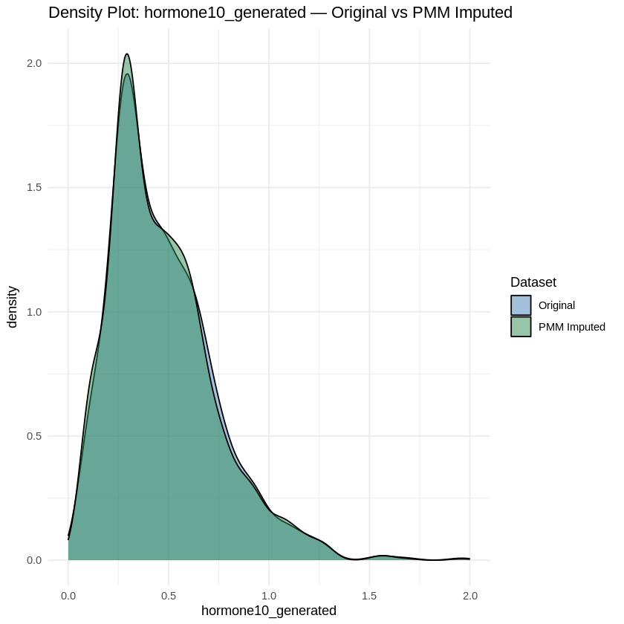
Figure 4 — Density comparison: Original distribution (blue) vs Predictive Mean Matching imputed values (green).
The Predictive Mean Matching (PMM) imputation yields an equally high-quality result. The green and blue curves are nearly indistinguishable in shape, peak location (~0.3), and tail behaviour. PMM explicitly draws imputed values from observed data points, which guarantees that imputed values are plausible and within the range of real measurements — a key advantage over parametric methods.

Criteria | Random Forest (RF) | Predictive Mean Matching (PMM)
Distribution match | Excellent — near-identical to original | Excellent — near-identical to original
Value plausibility | Good — model-generated predictions | Guaranteed — drawn from observed values
Computational cost | Higher (ensemble model) | Lower (regression-based)
Recommendation | Preferred for complex non-linear relationships | Preferred when interpretability matters

Both methods performed well on this dataset. The RF-imputed dataset was used in downstream outlier analysis.

4. Outlier Detection
Following imputation, outlier detection was performed using boxplots. All outliers are defined as values falling beyond 1.5× the interquartile range (IQR) from the box boundaries. Analysis was conducted in two stages: first on lipid variables specifically, then across all numeric variables.

Figure 5: Lipid Variables — Outlier Detection
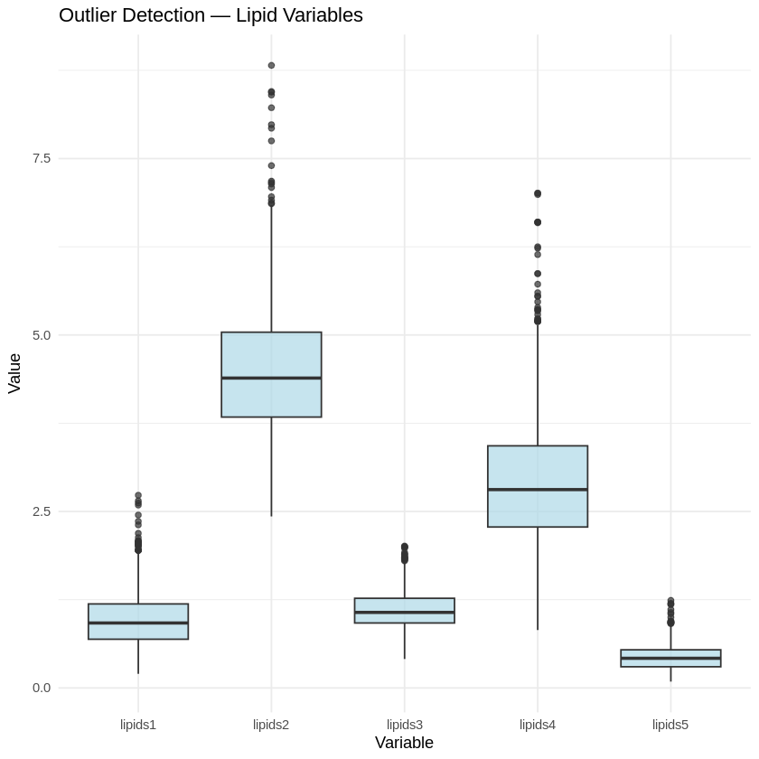
Figure 5 — Boxplots for lipids1–5 showing inter-variable scale differences and outlier points.
The five lipid variables show substantially different scales and outlier profiles:
- lipids2 has the widest spread (IQR ~3.7–5.0) with numerous high-end outliers extending above 7.5, indicating a heavy right tail. This variable warrants careful treatment before modelling.
- lipids4 also shows considerable spread (IQR ~2.5–3.5) with several extreme outliers reaching ~6.5.
- lipids1 and lipids3 are compact (IQR ~1.0–1.5) with only a small number of high-value outliers.
- lipids5 has the smallest scale (~0.25–0.75 IQR), with a handful of outliers near 1.2–1.4. Its tight distribution suggests a distinct measurement type from the other lipids.

Figure 6: All Numeric Variables — Comprehensive Outlier Detection
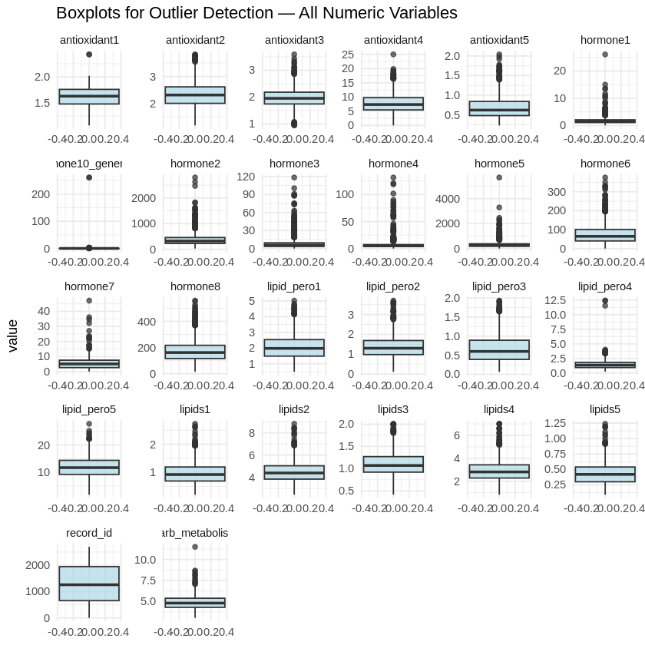
Figure 6 — Faceted boxplots across all 26 numeric variables post-imputation. Each panel uses a free y-axis scale.
The comprehensive faceted boxplot reveals important patterns across variable groups:
- Antioxidants (1–5): Compact distributions with few outliers. antioxidant4 shows the largest absolute range (0–25), while others cluster tightly between 1.5–2.5. Outliers are present but not extreme.
- Hormones (1–8, 10_generated): Highly variable scales. hormone2 reaches ~2,500, hormone5 ~4,000, hormone6 ~300. These variables exhibit strong right-skew with many outlier points — log-transformation may be advisable before modelling.
- hormone10_generated: Very compact near-zero distribution (~0–300), with a few high outliers.
- Lipid peroxidation markers (lipid_pero1–5): Generally moderate distributions. lipid_pero4 shows the widest range (~0–12.5) with several outliers. Others range from ~1–3.
- Lipids (1–5): Consistent with Figure 5 findings — variable scales, lipids2 and lipids4 having the most notable outlier contamination.
- carb_metabolism: Tight distribution (5.0–7.5) with only one visible outlier near 10.
- record_id: As expected, shows a near-uniform distribution — not meaningful for modelling.

5. Key Findings & Recommendations
Stage | Finding | Recommended Action
Missing Data | 5 variables >85% missing (hormone9, 11-14) | Remove from analysis — imputation not viable
Missing Data | hormone10_generated: 34.2% missing; lipids4/5: 24% | Impute — both RF and PMM give high-quality results
Imputation | RF and PMM both preserve original distributions | Prefer RF for complex data; PMM for interpretability
Outliers | lipids2, lipids4, hormone2/5/6 have most extreme outliers | Consider log-transform; evaluate clinically before removal
Scaling | Wide variation in variable scales (0.25 to ~4,000) | Normalise/standardise before any distance-based modelling

The preprocessing pipeline successfully transformed the raw dataset from 41 variables with 18.6% overall missingness into a clean, imputed 26-variable working dataset ready for downstream statistical modelling or machine learning. Both imputation methods demonstrated strong fidelity to the original data distribution, and outlier patterns have been documented for informed handling in subsequent analysis stages.

End of Report

